

Université de Bourgogne - Site universitaire du Creusot

Master in Computer Vision and Robotics

*Software Engineering Project*

*Weekly Progress Reports*

Pupil:

ASRAF ALI Abdul Salam Rasmi

SULAIMAN Jamilu

Guided By

Professor: Yohan Fougerolle

Tutor: Cansen Jiang

Tutor: David Strubel

**Introduction**

We are working on the Group 4 Project of the previous year (3D Scanner). At the beginning we couldn’t find the way the code is written but after getting some explanations from our friend in Dijon Campus, we were able to figure the sequence of the program. A schema was drawn by our friend to explain us the program sequence as shown below.

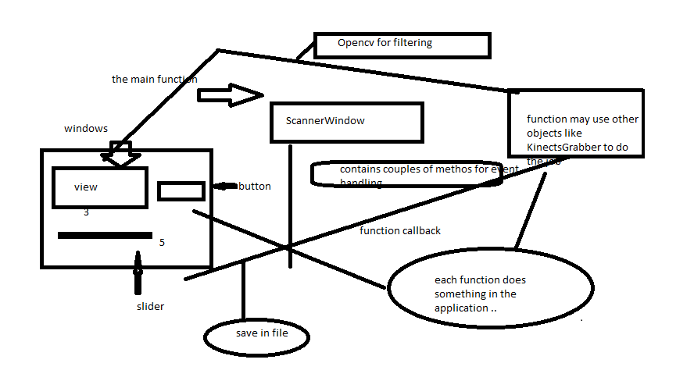

**Tasks Completed**

* After a huge bunch of errors finally we linked Qt with PCL, Visual Studio.
* We read the papers sent by Mr. Cansen regarding the PCL and right then we got clear idea on how to use the PCL Library.
* Since the sequences of the codes were explained by our friend we directly went into the process of enhancing the codes.

**Tasks in Process**

* Right now Jamil is working on enhancing the codes and resolving the errors occurred while running the program.
* We would like to use open CV and right now we are reviewing the concepts of Open CV.
* On the other hand Abdul is trying to segregate the codes into different classes.

**Future Tasks**

* The codes must be tested with the kinect Grabber which is yet to be done.
* Once the individual tasks are completed, the changes in the codes must be redefined without affecting the segregation of classes.
* Both of our team members are not aware of writing reports in Latex so we need to learn that sooner.